Major (12U) Rules – MOCO Game Rules

**USSSA rules to be followed with the exception of the rule modifications listed below.** USSSA rules available at:
https://www.usssa.com/fastpitch/fastpitch-rules-legal-information[CL1]

FIELD SETUP (See diagram at end of rules)

- The bases for Junior and Minor level are at 60 feet
- The pitching distance is 40' for Majors (12U) and is determined from the back point of home plate to the front of the pitching plate.
- The circle is 16 feet in diameter.
- All fields need to have running lanes going to First base
- All fields should have coaches' boxes at First and Third

Playing Equipment
- Majors (12U) play with a 12" optic yellow softball with a 0.47 core and 375 lb compress10n.
- Bats must be stamped with the USSSA certification seal.
- All helmets must be equipped with a facemask that is approved by the National Operating Committee on Standards for Athletic Equipment and must be worn properly.
- No steel cleats.
- All players must be wearing their respective team uniforms to participate in a game. A minimal team uniform shall be defined as a set of matching shirts with numbers on the backs

Game Rules
- Each game will have a time limit of one hour and thirty minutes, or six (6) complete innings, whichever occurs first. A new inning is not to begin after either of these occur, unless the score is tied. When the game ends in a tie, full innings shall be played until the score at the end of a full inning yields a winner. If weather delays a game, the game time clock shall be paused until play resumes.
- Last inning is defined as the inning before the time limit expires does not have to be the 6th inning. The umpire will determine when the time limit warrants a notification to both head coaches that the last inning is to begin. 30 minutes remaining
- In all divisions, the offensive team shall be limited to seven (7) runs or three (3) outs per inning, whichever comes first.
- A team roster consisting of players first and last name and number and official batting order shall be presented before the start of each game, to the coach of the opposing team.
- Managers, coaches and team members shall conduct themselves at all times while on the field or at the game site with propriety. (The use of profanity, alcohol or tobacco at the game site or in the presence of the players shall be considered as misconduct.
- All teams shall have at least one responsible adult (not a player coach) at each game played.
- The home team shall provide all umpires. YOU MUST USE AT MINIMUM 1 CERTIFIED USSSA UMPIRE.
- Teams shall field no more than nine (9) players with no fewer than seven. As long as seven players can be fielded, there shall be no forfeit or rescheduling of the game. Teams fielding less than nine (9) players will not be penalized with outs at the empty spots in the batting order. There is no maximum number of players that can be on a team, only a max number of fielders, and all players on the team shall be listed on the batting order.
- Alternate Rule:
  - During Regular Season – Teams can use alternates to bring the team up to 10 players. Alternates have to be added to the bottom of the batting order and play in the outfield.
  - During Tournament Play – Teams only can use alternates if they cannot field 7 players. Alternates can only fill the roster up to 7 players, and they have to be added to the bottom of the batting order and play in the outfield.
- All players will be listed on the batting order and will bat in that order. Any late arrivals to the game will be added to the end of the roster (batting order). There is free substitution on defense. Any player skipped will set out 6 consecutive outs.
- Pinch-runners allowed for pitcher or catcher. Pinch-runner is to be the player who made the previous out.
- Infield fly rule applies
- All play will stop upon injury to player.
- If batter is injured during the current game she can be skipped as a batter without taking an out.
- An official game: Majors(12U) is four (4) innings, if called for weather (which is determined at the discretion of the umpire). If the home team is ahead in the bottom of the fourth (4th) inning.
- 10-Run Rule is in effect. If after four (4) innings are complete a team leads by ten (10) or more runs, the game will be called. If the time limit has not been reached, the coaches may agree to continue the game for instructional purposes. However, the final score will be what was recorded at the time the rule was enforced.
- Regular season games will end in a tie if the time limit is up and the home team has batted.
  - The tie breaker rule will only be in effect for tournament play and will be as follows:
    - The last batter from the previous inning will go to second base and become a base runner. The next person in the line-up will bat and will continue to go through the line-up until three outs or seven runs have been scored. The opposing team will do the same until one team goes up by at least one run. You do NOT start with any outs.

Code of Conduct
- Coaches are responsible for the conduct of themselves, other coaches, their players and the spectators.
- The home plate umpire has the final decision regarding all rules and plays.
  - On ANY play in which the umpire makes a call (safe/out, dead ball, foul ball, runner making the halfway point between bases), his call is to be respected and followed.
  - Coaches are not to argue these calls with the umpire, as his decision is final. Coaches may ask for clarification, as long as it is not in a confrontational or disrespectful manner.
- The umpire holds the authority of removal of a player, coach or parent that acts in a confrontational or disrespectful manner toward another player, coach, spectator or official.
  - The umpire’s decision is final and is to be followed immediately. Failure to do so will be reported to league officials and may result in removal from team and/or banishment from our facilities.
  - Any coach, assistant coach, umpire or attendee that is ejected will be reported and documented to their respective boards. If you fail to appear before the Board any child you are associated with will not be allowed to play until you have appeared before the board.
- Both teams will keep score, with home team being the official book.
- Home team is responsible for preparing the field before the game and clean up of field/dugouts after.

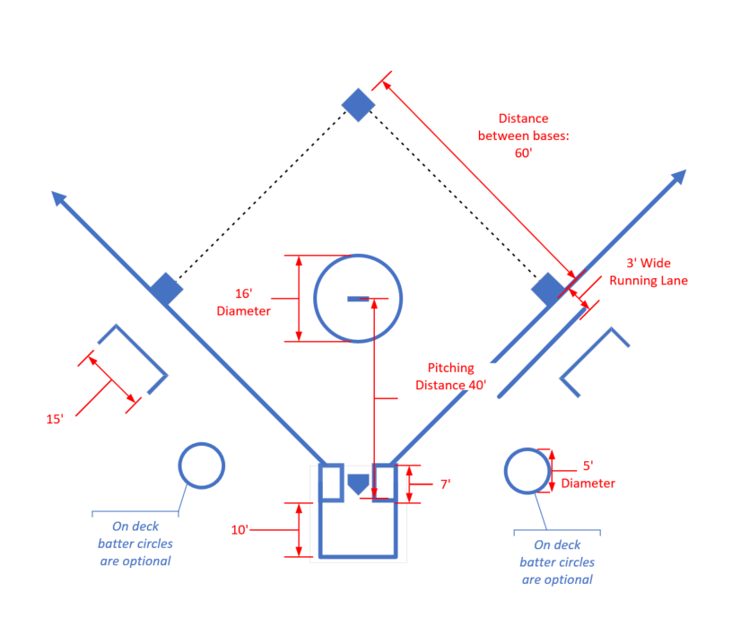

Special WEBO References to USSSA Rules for coaches:
- INTERFERENCE. Interference is an act that denies a defensive player a reasonable opportunity to make a play (field/throw) anywhere on the playing field. The act may be intentional or unintentional, and the ball must be playable.
  - Offensive interference is interference (physical or verbal) by the team at bat, or when a runner creates malicious contact with any fielder with or without the ball, in or out of the baseline; or when a coach physically assists a runner during playing action.
  - Umpire interference is when the Umpire, inadvertently moves so as to hinder a catcher’s attempt to throw or when a fair, untouched ball touches an Umpire before the closest infielder has a reasonable opportunity to field the ball.
  - Spectator interference is any action by a spectator, which impedes the progress of the game
- OBSTRUCTION. Obstruction is the act of the defensive team member that hinders or impedes a batter’s attempt to make contact with a pitched ball, or that impedes the progress of a runner or batter-runner who is legally running bases, unless the fielder is in possession of the ball or is making the initial play on a batted ball. The act may be intentional or unintentional, physical or verbal.
  - It is catcher obstruction when a catcher hinders or prevents a batter from swinging at a pitch.
  - A fake tag is an act by a defensive player that simulates an attempt to tag a runner. Faking a tag is considered obstruction.

- RULE 8. Base Running Sec 1. Stealing of bases permitted.
- RULE 8. Base Running Sec 2. The LOOK-BACK RULE is in effect when the ball is live, the batter-runner has touched first base or has been declared out, and the pitcher has possession of the ball (e.g. has the ball in their hand, glove, under arm or chin, between their legs) within the 16-foot circle. Any runner(s) in motion may continue without stopping or may stop once. Any runner who is stopped or stops their motion must immediately move directly back to the last base touched or attempt to advance to the next base. Once the runner stops at a base for any reason, they may not move off that base. A batter-runner who overruns first and does not without delay attempt to advance to second is committed to return to first and stop. The runner, off base, may not stand motionless. There does not need to be any motion or recognition by the pitcher. Failure of the runner to respond as indicated shall cause the Umpire to signal the runner out. The ball shall be declared dead. If the pitcher no longer has possession of the ball within the 16-foot circle, the pitcher makes an attempt on any of the runners or a fake throw is made, this rule does not apply. Being in the 16-foot circle is defined as both feet within or partially within the line. The feet may touch the line and extend outside the line. When the pitcher is in the pitcher’s circle and a runner(s) is off the base, the pitcher is considered to be playing on the runner(s) when the throwing arm is raised or any forward movement of the body is made toward the runner. Movement of the head is not considered an attempted play. EFFECT: The ball becomes dead immediately. The runner is out.
- RULE 8. Base Running Sec 7. A Runner may advance with liability to be put out.
  - When the ball leaves the pitcher’s hand on the delivery.
  - On a thrown ball or a fair batted ball that is not blocked.
  - On a thrown ball that hits an Umpire.
  - If a batted ball (fair or foul other than a foul tip) is caught, the initial contact of the ball by a fielder releases the runner(s) from the base(s) occupied at the time of the pitch.
  - If a fair ball strikes an Umpire or a runner after having passed an infielder other than the pitcher, and provided no other fielder had a chance to make an out, or when a fair batted ball has been touched by an infielder, including the pitcher, and the runner did not intentionally interfere with the batted ball or the fielder attempting to field the batted ball. EFFECT- Section 7: The ball is in play.
- RULE 8. Base Running Sec 13: When a runner is obstructed while advancing or returning to a base, by a fielder who neither has the ball nor is attempting an initial play on a batted ball, it shall be a delayed dead-ball. Obstruction shall not be enforced when the batter flies out for the third out, or when the batter-runner is obstructed between two bases when she flies out. EFFECT: If the obstructed runner is put out prior to reaching the base that would have been reached had there not been obstruction, a dead ball is declared and the Umpire shall award the obstructed runner, and each other runner affected by the obstruction, the bases they would have reached, in the Umpire’s judgment, had there been no obstruction.
- RULE 8. Base Running Sec 18. Any runner is out when the runner:
  - Runs more than three feet away from the base path to avoid being tagged, or to hinder a fielder while the runner is advancing or returning to a base. EXCEPTION: This is not an infraction if a fielder, attempting to make an initial play on a batted ball, is in the runner’s proper path and if the runner runs behind the fielder to avoid interfering. NOTE: When a play is being made on a runner or batter-runner, the runner establishes their base path as directly between the runner’s position and the base toward which the runner is moving.
  - slides illegally and causes illegal contact and/or illegally alters the actions of a fielder in the immediate act of making a play on her. PENALTY: The runner is out and the ball is dead immediately and interference is called. NOTE: Runners are never required to slide but, if the runner elects to slide, the slide shall be legal.
  - does not legally attempt to avoid a fielder in the immediate act of making a play on her. PENALTY: The runner is out and the ball remains live unless interference is called. NOTE: Jumping, hurdling, and leaping are all legal attempts to avoid a fielder only if the fielder is lying on the ground.
  - Performs Malicious contact (always supersedes obstruction).
  - does not attempt to avoid the fielder on a force play. NOTE: a legal slide is considered an attempt to avoid.
  - Interferes with a fielder attempting to throw the ball, or intentionally with a fielder or thrown ball.
  - Hinders a fielder’s initial play on a batted ball.
  - Interferes with a fielder attempting to field a fly ball over foul territory. EFFECT: The ball is dead and the runner is out. The batter is assessed a foul ball in this situation.Drop 3rd Strike Run IS in effect

- RULE 10. DEAD BALL – SUSPENSION OF PLAY Sec 1. The ball becomes dead immediately when:
  - A pitch touches a batter or the batter’s clothing. NOTE: the ball becomes dead even though the batter strikes at it.
  - The ball is illegally batted or comes in contact with the bat a second time. except if the ball rolls against the bat in fair territory as in Rule 7-14-F NOTE.
  - The batter is discovered with an illegal bat.
  - Any batted ball, while on or over foul ground. 1. Touches any object other than the ground or any person other than a fielder. 2. Goes directly from the bat to the catcher’s protector, mask or person without first touching the catcher’s glove or hand. 3. Becomes an uncaught foul.
  - There is interference by a batter, a runner or a retired runner.
  - A fair ball, which is on or over fair ground. 1. Touches a runner or an Umpire before touching any fielder and before passing any fielder other than the pitcher. Touches a runner after passing through or by an infielder and another fielder could have made a play on the ball. 3. Touches a spectator. 4. Goes over, through or wedges in the field fence.
  - A pitch or any other thrown ball 1. Is touched by a spectator. 2. Is touched by nonparticipating team personnel. 3. Goes into a stand or player’s bench (even if it rebounds to the field). 4. Goes over or through or wedges in the field fence. 5. Lodges in an Umpire’s or catcher’s equipment or touches loose equipment.
  - The Umpire handles a live ball, calls “Time” for inspecting the ball, or for any other reason.
  - A fielder, after catching a fair or foul ball (fly or line drive), leaves the field of play by stepping with both feet or by falling into a designated dead-ball area (i.e., bench, dugout, stand/bleacher, etc.). NOTE: if a chalk line is used to designate an “out-of-play” area, the line is considered in play. If a fielder is touching the line, they are in the field of play and may make a catch. When the fielder completely unintentionally leaves live-ball area and then re-establishes himself within live-ball territory (one foot touching out of play line), a catch would be allowed. If the fielder unintentionally leaves a live-ball area with both feet after making a catch, the ball becomes dead and all base runners are awarded one base from the time of the pitch. Two bases shall be awarded each runner if a fielder intentionally leaves live-ball area with both feet.
  - Any personnel connected with the offensive team requests “Time” or uses any other command or commits an act for the purpose of trying to cause the opposing pitcher to commit an illegal pitch.
  - An infielder intentionally drops a fair fly. EXCEPTION: Infield Fly Rule.
  - A runner interferes with a fielder attempting to catch a foul fly.
  - The batter-runner moves backward toward home plate to avoid or delay being tagged out.
  - A batted, thrown or pitched ball touches in an occupied designated media area (a ball that passes through a dead-ball area in flight is not considered dead).
  - An illegal pitch occurs, but no pitch is delivered to the batter.
  - The Umpire calls Time Out for an Injured Player per Rule 5-9-A.
- RULE 10. DEAD BALL – Sec 2. It is a delayed dead ball when:
- An illegal pitch is delivered.
- B. A catcher or any fielder obstructs a batter or obstructs the ball through use of detached play equipment.
- C. The Umpire interferes with catcher who is attempting to throw. EFFECT: If the runner is not out, they are returned to the last base attained before the interference occurred.
- D. A coach physically assists a runner. E. A ball touches an illegal glove/mitt.
- F. Any one who is required to wear a batting helmet deliberately removes the helmet while the ball is live.

- RULE 10. DEAD BALL – Sec 3. The ball becomes dead when time is taken to make an award when a catcher or any fielder illegally obstructs a runner.

- RULE 10. DEAD BALL – Sec 4. After a dead-ball situation, the ball becomes live when it is held by the pitcher within the 16-foot circle and the Umpire calls and/or signals “Play Ball”.

- RULE 10. DEAD BALL – Sec 5. “Time” shall be called by the Umpire and play suspended:
- When the Umpire and/ or Tournament Director considers the weather or ground conditions unfit for play. NOTE: After 30 minutes, the Umpire and/ or Tournament Director may declare the game ended or suspended.
- B. When a player, bench personnel or spectator is ordered from the field of play, or player is ordered to secure protective equipment.
- C. When a player or coach is granted time for a substitution, conference with the pitcher, or for similar cause.
- D. When play is suspended for any other cause, including an award of a base after an infraction, inspection of the ball, or the ending of a half-inning.

- RULE 10. DEAD BALL – Sec 6. When the ball becomes dead:
  - No action by the defense during that time can cause a player to be put out, except a proper dead-ball appeal.
  - B. A runner may not advance, nor return to a base that was not touched or that the runner was not in contact with on a caught fly ball during a live ball if the runner had advanced to or beyond a succeeding base.
  - C. Any runner may advance when awarded a base or bases for an act, which occurred before the ball became dead. All awarded bases must be touched

